**ASSIGNMENT -2**

**Pharma Sales Dashboard**

|  |  |
| --- | --- |
| Student Name | MANJULA S |
| Student Roll Number | 921319104110 |

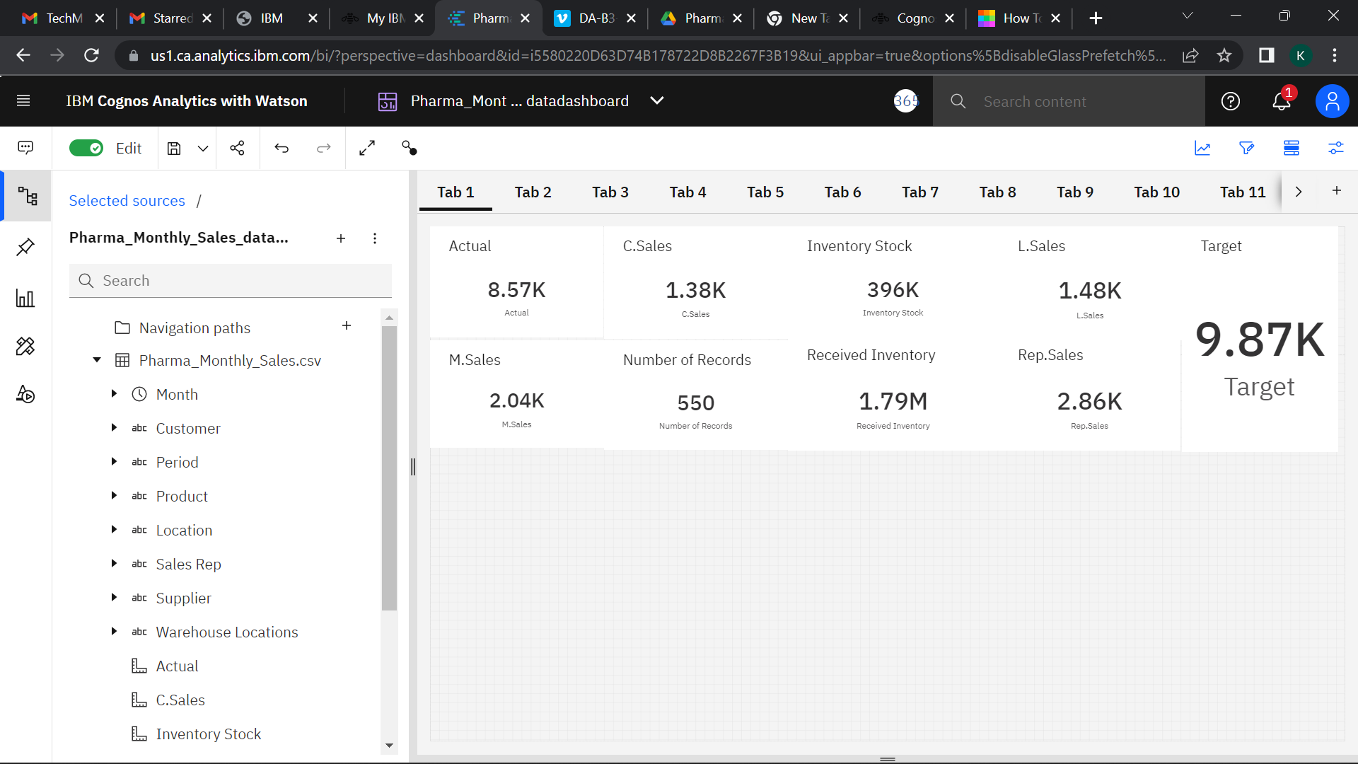

**SALES BY CUSTOMER**

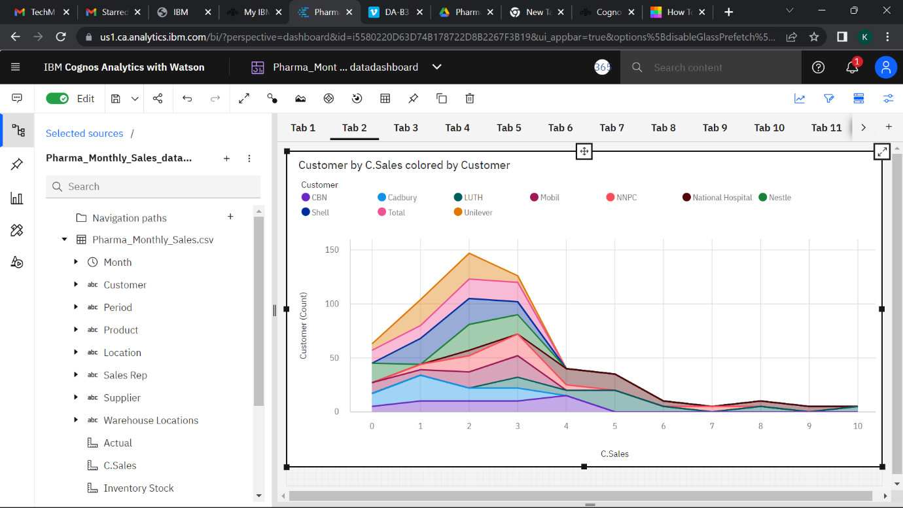

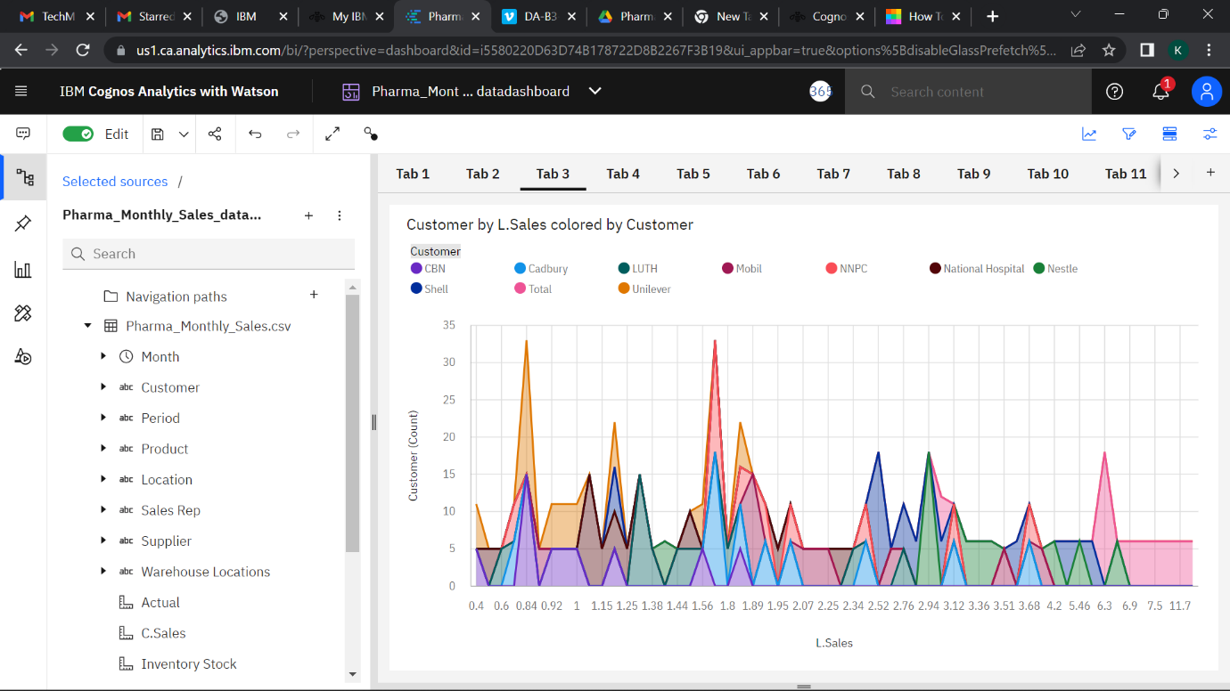

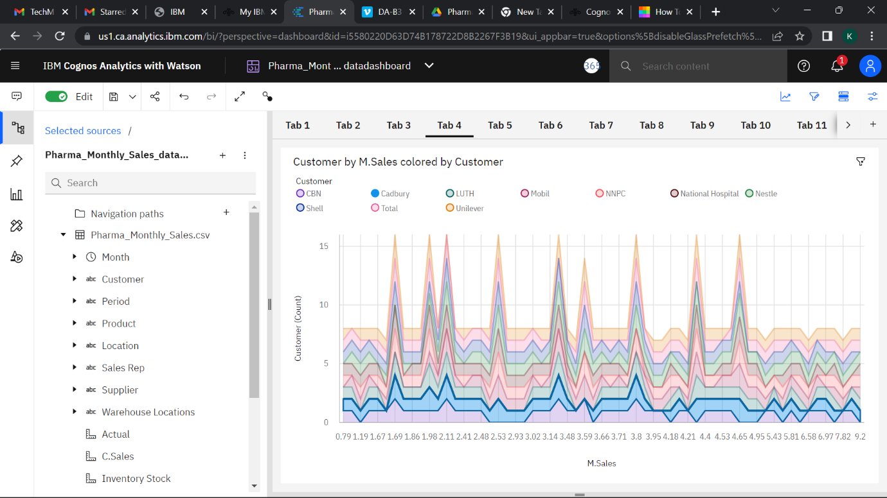

**SALES BY LOCATION**

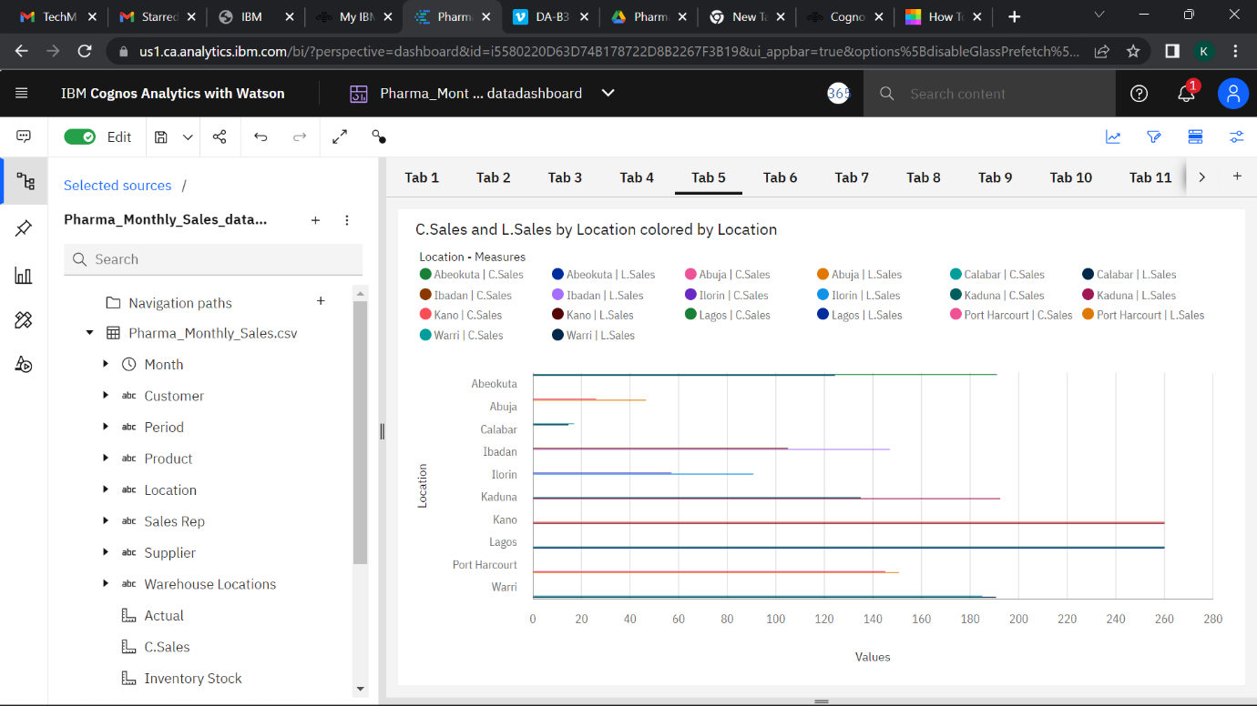

**SALES BY SALES REPRESENTATIVE**

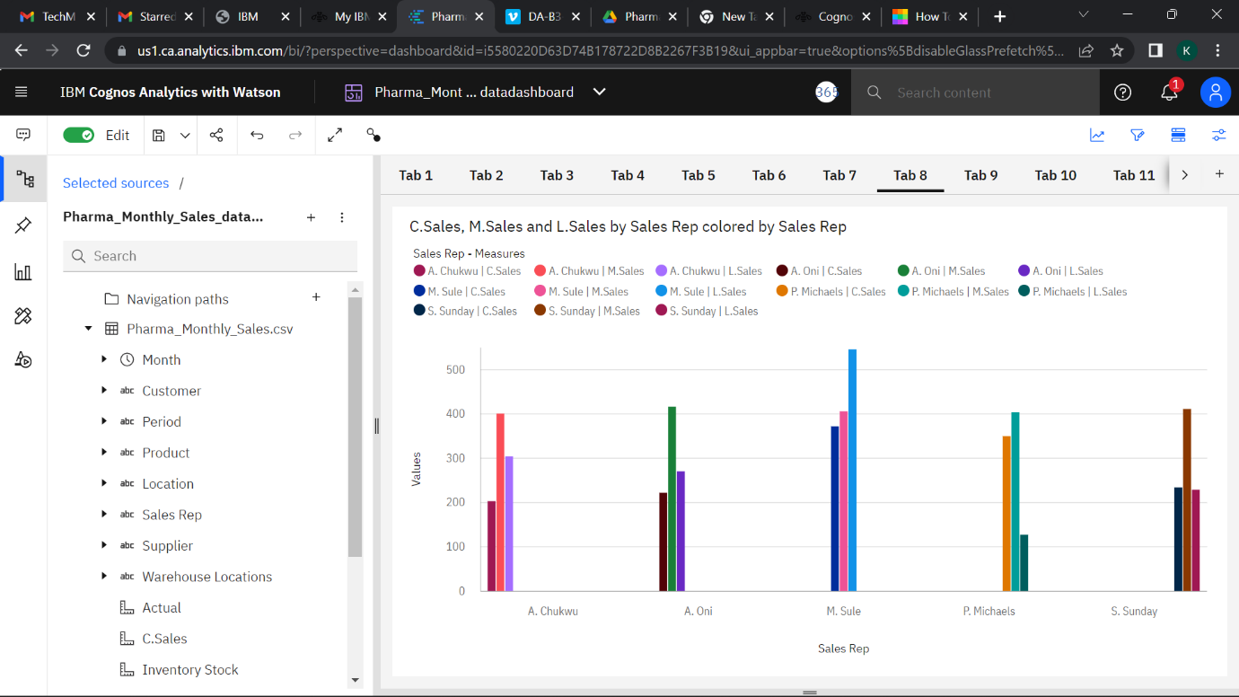

**RECEIVED INVENTORY FROM SUPPLIER**

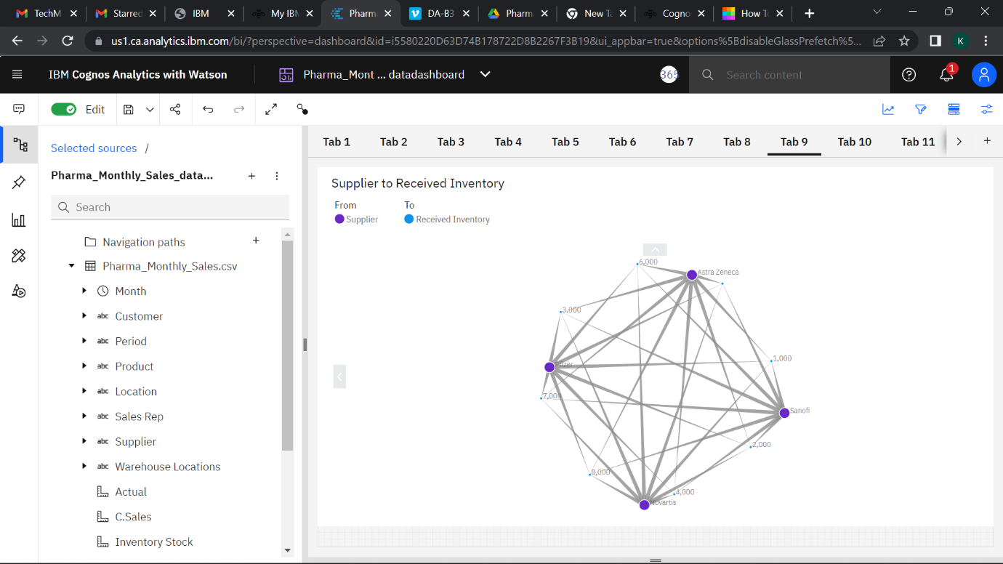

**INVENTORY STOCK FOR WAREHOUSE LOCATIONS**

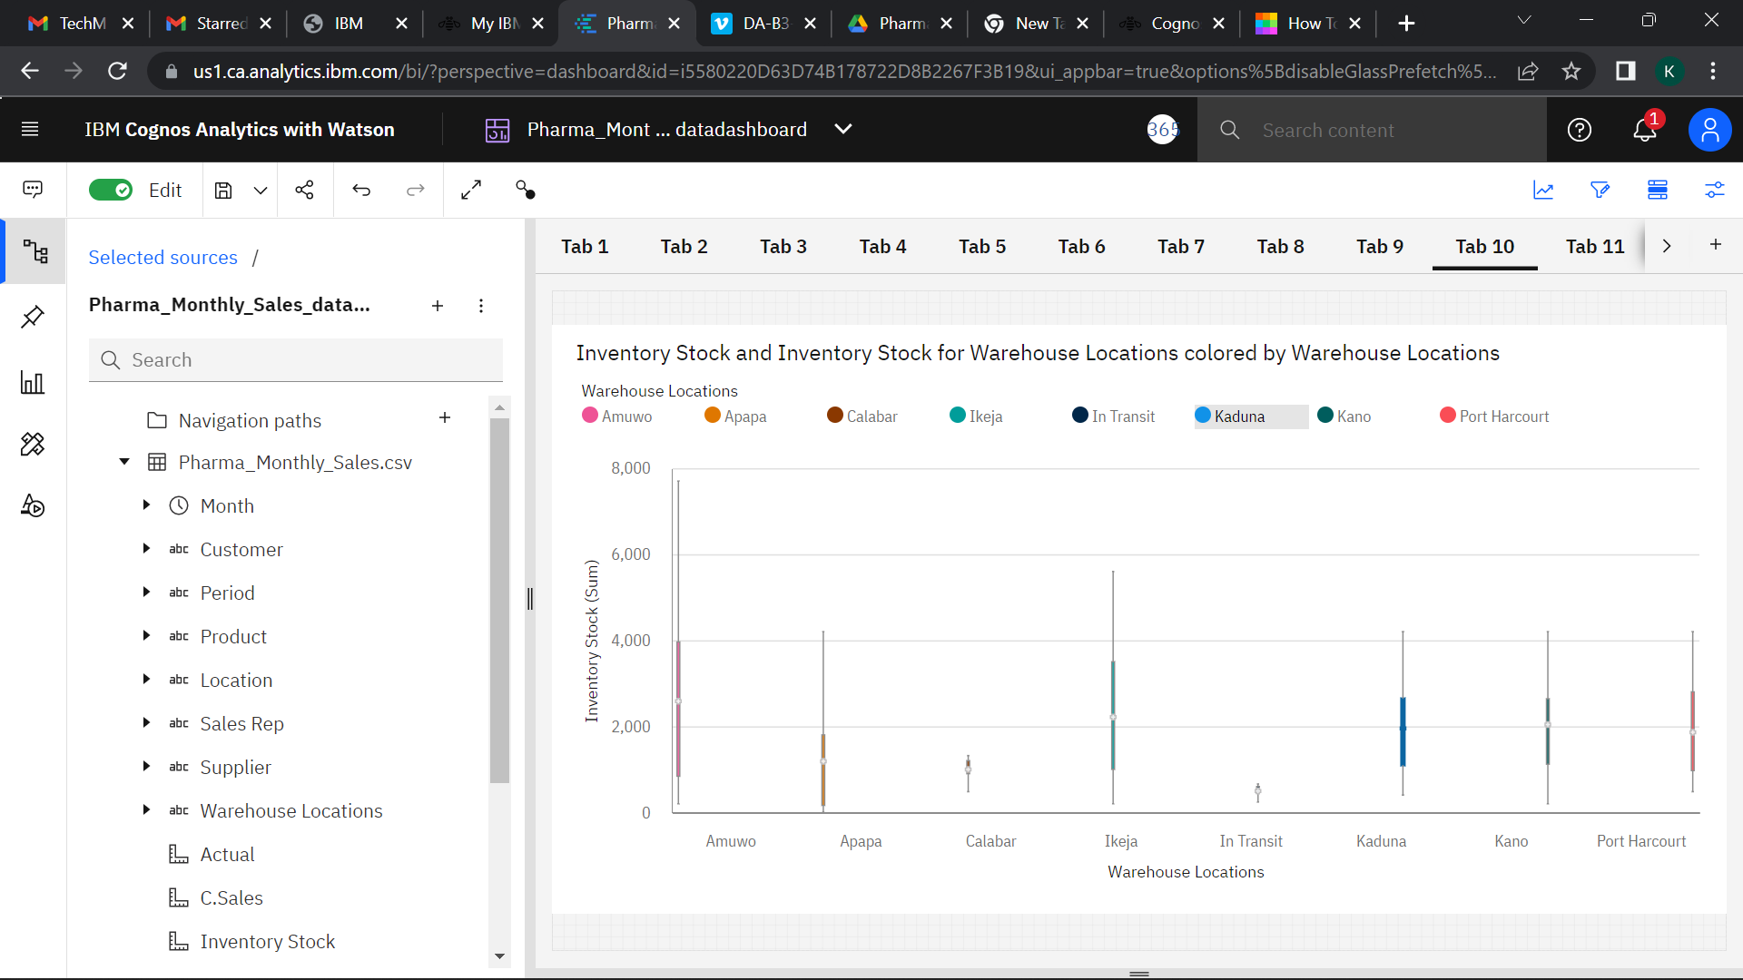

**ACTUAL AND RECEIVED INVENTORY BY MONTH** 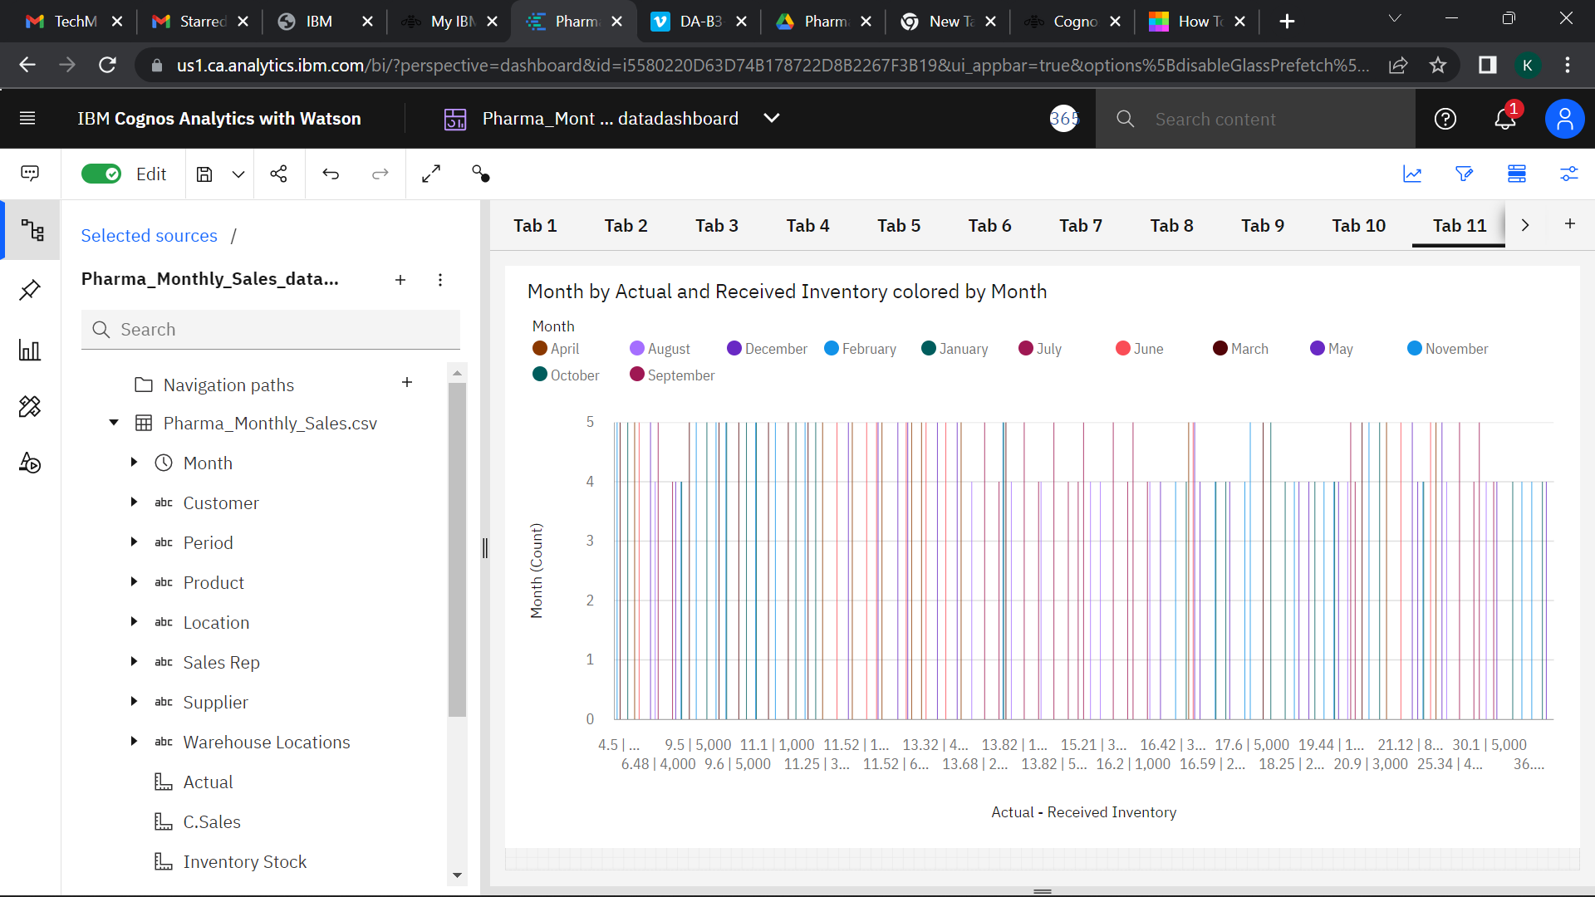

**SALES TREND**

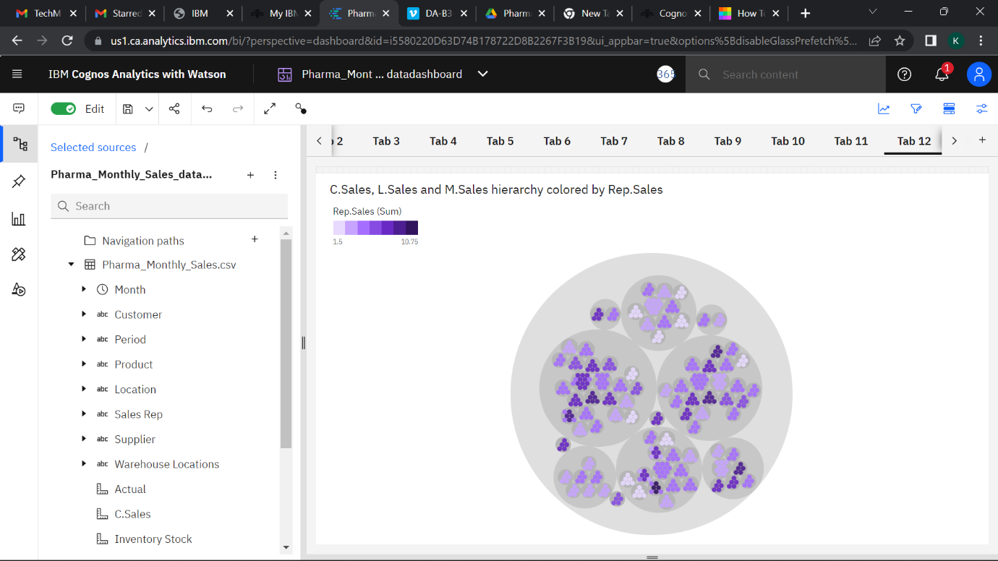

**MONTHLY SALES**

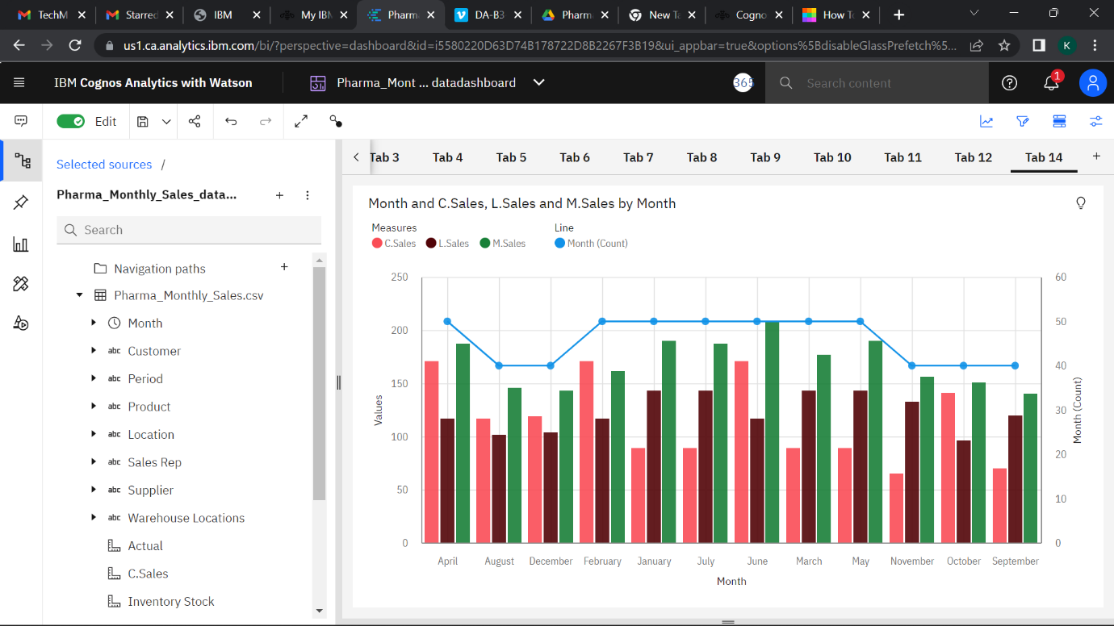

**IBM EXPLORE LINK**

<https://us1.ca.analytics.ibm.com/bi/?perspective=explore&pathRef=.my_folders%2FPharma_Monthly_Sales_dataexplore&subView=model0000018373fb0970_00000001>

**IBM DASHBOARD LINK**

<https://us1.ca.analytics.ibm.com/bi/?perspective=dashboard&pathRef=.my_folders%2FPharma_Monthly_Sales_datadashboard&action=view&mode=dashboard&subView=model00000183742b8da0_00000000>